**AI-Driven Tourism Recommendation System**

**for Local Tour Guides**

October 20, 2024 - By Anisha Mohanty

Github Link: https://github.com/anisha9658/Tourism-Recommendations-System

**Abstract:** The tourism industry faced significant challenges due to the COVID-19 pandemic, leading to a decline in travel and tourist activities. This has particularly affected local tour guides and small-scale tourism businesses, who rely heavily on tourists for their livelihood.

In this report, I propose an **AI-Driven Tourism Recommendation System** that aims to enhance the travel experiences of tourists while boosting the business opportunities for local tour guides. The recommendation system uses a hybrid approach, combining **Collaborative Filtering** and **Content-Based Filtering** techniques, to provide personalized travel recommendations based on tourists' preferences, previous travel history, and interests.

This recommendation system is designed to help local guides identify and connect with tourists who are most likely to enjoy their tours, thereby increasing their chances of securing bookings. It also allows tourists to discover activities and places that align with their interests, creating a more engaging and fulfilling travel experience. The report includes a prototype implementation and a step-by-step explanation of the model's development, integration, and potential business impact.

**1.Problem Statement**

The tourism industry, especially local tour guides and small-scale tourism businesses, has been significantly impacted due to changing travel trends and post-pandemic recovery challenges. It has become crucial for local guides to attract tourists by offering tailored experiences that match their interests. However, many guides lack the resources and expertise to identify what tourists might enjoy based on their preferences and travel history.

This project aims to **predict similarities in tourists' interests and provide tailored recommendations** for local experiences, tours, and activities. By identifying what types of tours are more likely to be enjoyed by different tourists, guides can better manage their offerings and promote the right experiences to the right visitors, ultimately increasing their bookings and revenue.

The recommendation technique is based on the idea that if a tourist has shown interest in certain types of activities or places, they are likely to enjoy other similar experiences. For example, if a tourist enjoys hiking, they are more likely to appreciate recommendations for nature trails or adventure tours nearby.

**2. Market/Customer/Business Need Assessment**

The tourism sector, especially for local tour guides and small-scale tourism businesses, has experienced significant setbacks due to the COVID-19 pandemic. Travel restrictions and safety concerns led to a decline in tourism, shifting travelers' preferences towards online trip planning and virtual experiences. As a result, local guides have found it challenging to attract tourists and maintain steady bookings.

To recover from these challenges, it is essential for local guides to **adapt their services** and provide personalized travel experiences that align with tourists' preferences and interests. By understanding what types of experiences tourists enjoy, guides can optimize their offerings, target specific groups, and attract more bookings.

The AI-Driven Tourism Recommendation System aims to provide **data-driven insights** into tourist preferences, enabling guides to effectively promote their tours and activities. This system offers the potential for local guides to increase their visibility and appeal by recommending personalized experiences that match travelers' desires, ultimately leading to higher engagement, better customer satisfaction, and increased revenue opportunities for small-scale tourism businesses.

**3. Target Specifications and Characterization**

1. **Increased Engagement for Local Guides**: With the use of this recommendation system, local tour guides can understand the types of experiences that attract tourists, such as adventure tours, cultural experiences, or culinary trips. This insight allows them to focus on promoting tours that are more appealing to tourists, helping them optimize their offerings and boost bookings. By targeting specific interests, guides can ensure that their time and resources are invested in high-demand tours, improving their revenue.
2. **Enhanced Tourist Satisfaction**: Using the analysis generated by the recommendation system, local guides can offer more personalized travel experiences to tourists, making their trips more enjoyable and fulfilling. By matching tourists with experiences based on their preferences, guides can improve the overall satisfaction of their clients, making them more likely to return or recommend the tours to others. For example, a tourist interested in nature walks could be directed to scenic trails and parks, while another with a taste for local cuisine might be recommended food tours and traditional cooking classes.
3. **Promotional Opportunities for Guides**: The system can help local guides create targeted promotional offers based on tourists’ interests and travel history. For example, a guide might offer a discount on city tours when a tourist books a historical monument visit, as these activities often attract the same type of traveler. By bundling related experiences or offering special deals, guides can increase their attractiveness to tourists, encouraging them to explore more and stay longer, which in turn boosts the guide's income and visibility in the competitive tourism market.

**4. External Search (Information and Data Analysis)**

These are some of the sources I consulted for further insights and understanding of the need for personalized travel recommendations and their impact on local tourism:

1. **Why Personalized Travel Recommendations Are Key to Modern Tourism**This source highlights the growing importance of personalized travel experiences in attracting tourists and retaining their interest. It emphasizes how tailored recommendations can significantly enhance the tourist experience, leading to higher satisfaction and repeat visits.
2. **The Role of AI in Reviving Post-Pandemic Tourism**This article explores how AI-based solutions like recommendation systems can help the tourism industry recover after the pandemic by offering personalized suggestions to travelers, thus increasing engagement and bookings for local guides.
3. **Benefits of Hybrid Recommendation Systems in the Tourism Industry**This source provides an in-depth look at the advantages of combining collaborative filtering and content-based filtering techniques to deliver highly relevant travel recommendations, ensuring tourists find experiences that match their interests and preferences.

**Dataset Description:** I am going to use the following datasets for my code implementation in this report:

1. **City Dataset**: Includes CityId, CityName, and CountryId for 9143 entries, providing information about various cities and their associated countries.
2. **Continent Dataset**: Contains ContenentId and Contenent with 6 entries, helping categorize countries into their respective continents.
3. **Country Dataset**: Features CountryId, Country, and RegionId with 165 entries, enabling a mapping between countries and regions.
4. **Attraction Dataset**: Provides data on AttractionId, AttractionCityId, AttractionTypeId, Attraction, and AttractionAddress for 30 different attractions, allowing the recommendation system to identify points of interest.
5. **Visit Mode Dataset**: Contains VisitModeId and VisitMode with 6 entries, specifying different modes of travel or visit preferences (e.g., guided tours, self-exploration).
6. **Region Dataset**: Includes Region, RegionId, and ContentId with 22 entries, helping categorize different regions for targeted recommendations.
7. **Transaction Dataset**: Contains details about user visits and ratings, including TransactionId, UserId, VisitYear, VisitMonth, VisitMode, AttractionId, and Rating for 52930 entries. This dataset is crucial for analyzing tourist behavior and preferences over time.

These datasets capture the interactions between tourists, local guides, and attractions, making it possible to identify patterns and preferences that can be used to create personalized travel suggestions. By analyzing this data, the recommendation system can effectively match tourists with activities and guides that align with their interests.

**First import the basic libraries for data preprocessing:**

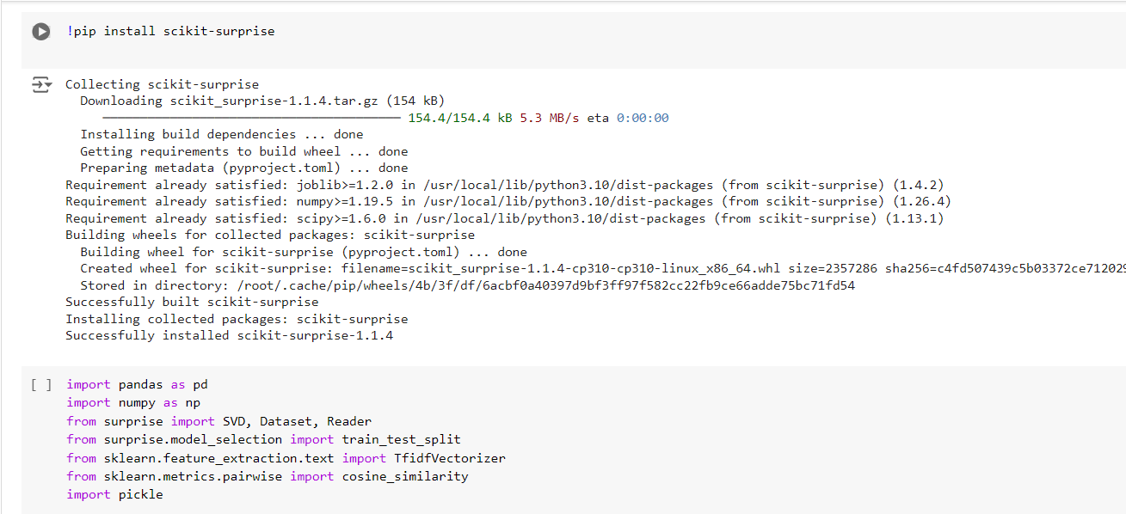

 Let's Load the Dataset:

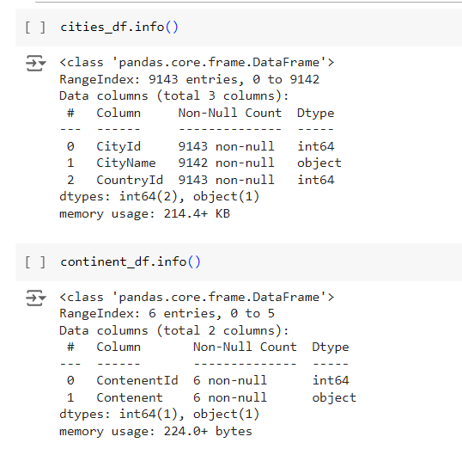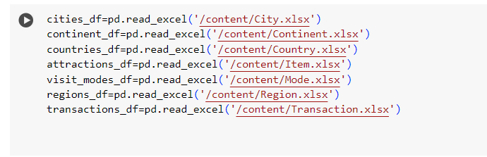

Let’s now see more info on our dataset:

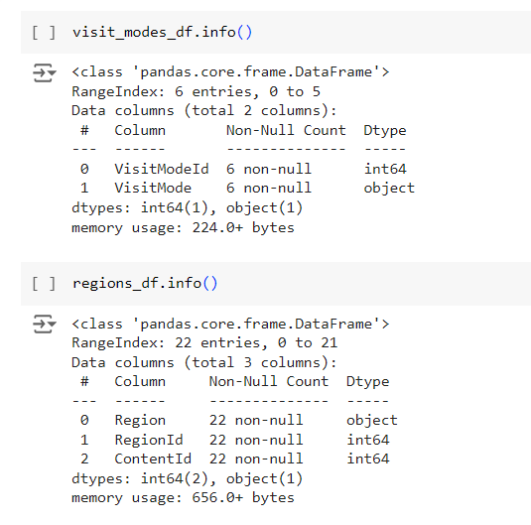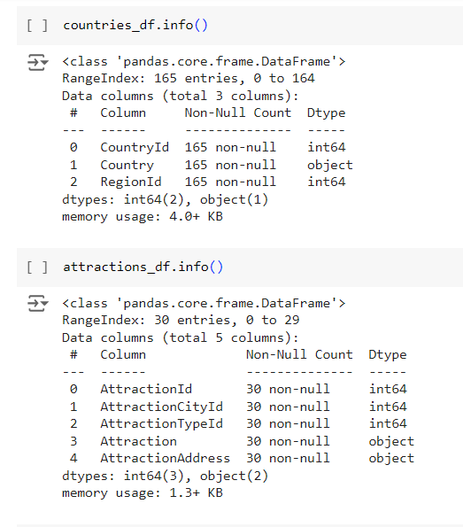

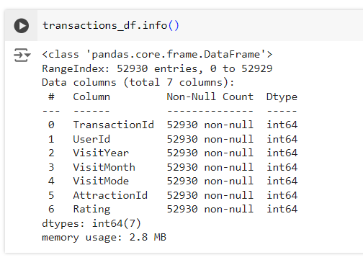

Let’s now see Data Overview: Unique Counts and Missing Values:

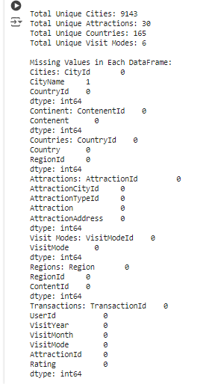

Visualization of Rating Distribution in Transactions: 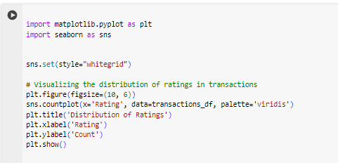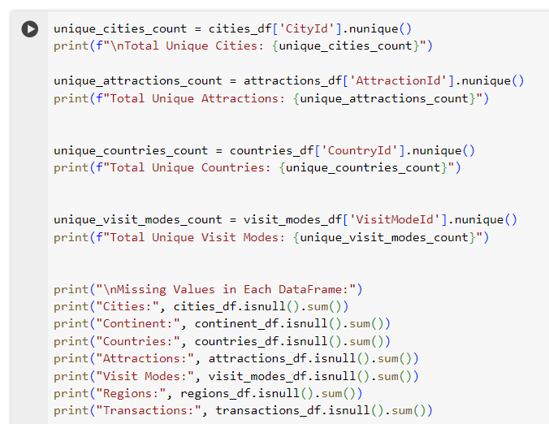

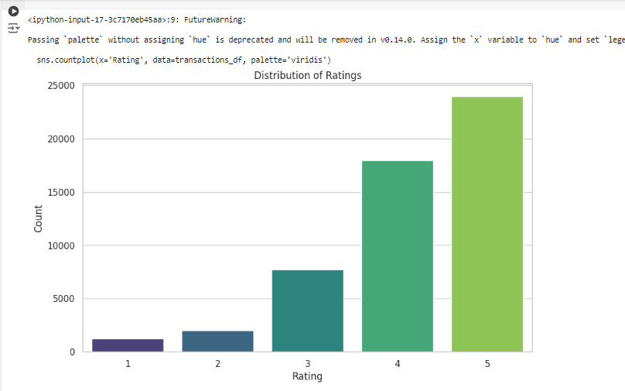

**5. Benchmarking**

Many e-commerce platforms, such as Amazon, Snapdeal, and Flipkart, leverage advanced recommendation techniques to enhance their sales and improve the overall shopping experience for customers.

**Key Points of Benchmarking:**

1. **Comparison with Industry Standards:**
   * Benchmarking involves comparing project processes and performance metrics against industry best practices or successful completed projects.
   * This ensures that the implemented techniques align with or exceed the standards set by leading e-commerce platforms.
2. **Continuous Improvement:**
   * There is a constant need to explore and adopt improved techniques that yield better results.
   * By analyzing successful implementations within the industry, businesses can identify gaps in their processes and strive for innovation.
3. **Focus on Customer Experience:**
   * Successful benchmarking emphasizes creating a seamless and personalized shopping experience for customers.
   * This leads to increased customer satisfaction, loyalty, and ultimately higher sales.

By incorporating these benchmarking practices, small-scale vendors and businesses can enhance their competitive edge in the market, driving growth and profitability.

**6. Applicable Patents**

To enhance the understanding and implementation of recommendation systems, several patents can provide valuable insights and methodologies. The following patents are relevant to market basket analysis and retail data mining:

1. **Method and System for Researching Product Dynamics in Market Baskets in Conjunction with Aggregate Market Basket Properties**
   * This patent describes a method for analyzing product dynamics within market baskets, allowing for a comprehensive understanding of consumer behavior and product relationships.
2. **Enhanced Market Basket Analysis**
   * This patent focuses on advanced techniques for market basket analysis, improving the accuracy and effectiveness of identifying product associations and customer purchasing patterns.
3. **Method and Apparatus for Retail Data Mining Using Pair-Wise Co-Occurrence Consistency**
   * This patent outlines a method for retail data mining that emphasizes the importance of pair-wise co-occurrence consistency, which can enhance the identification of frequently bought item combinations.

These patents can serve as valuable resources for developing innovative approaches to recommendation systems in the tourism sector, ultimately contributing to a more effective and user-centric solution.

**7. Applicable Regulations (Government and Environmental)**

When developing a tourism recommendation app, it's crucial to comply with various regulations that ensure ethical practices and promote fair business operations. The following regulations are relevant:

1. **Data Collection and Privacy Regulations of Customers**
   * Compliance with data protection laws, such as the General Data Protection Regulation (GDPR) or the California Consumer Privacy Act (CCPA), is essential. These regulations govern how customer data is collected, stored, and utilized, ensuring individuals' privacy rights are respected.
2. **Government Norms for Small Businesses and Street Vendors**
   * There are specific regulations that small businesses and street vendors must adhere to, including licensing requirements, health and safety standards, and operational guidelines that promote fair competition and consumer protection.
3. **Rules Against False Marketing**
   * Regulations exist to prevent deceptive advertising practices. Businesses must provide accurate information about their products and services, ensuring that marketing claims are truthful and not misleading to consumers.
4. **Employment Schemes and Laws Created by Government**
   * Governments often implement various employment laws and schemes to support small businesses and promote fair labor practices. Understanding these laws helps businesses navigate hiring, wage standards, and employee rights.

Adhering to these regulations not only fosters trust among customers but also contributes to the sustainable growth of small businesses within the tourism sector.

**8. Applicable Constraints**

While developing a tourism recommendation app for local tour guides, several constraints can impact its effectiveness and implementation. These include:

1. **Lack of Initial Data to Perform Algorithms**
   * Insufficient data can hinder the ability to accurately train algorithms, affecting the reliability of recommendations and insights.
2. **Convincing Shopkeepers and Vendors to Use This Technique Over Traditional Means**
   * Transitioning from traditional selling methods to data-driven approaches may be challenging. Gaining buy-in from shopkeepers and vendors is essential for successful implementation.
3. **Lack of Technical Knowledge Among Vendors**
   * Many vendors may not possess the necessary technical skills to understand or effectively utilize the recommendation system, which can limit its adoption.
4. **Rarely Bought Items Not Detected by Algorithm**
   * The algorithm may not generate recommendations for rarely purchased items, leading to gaps in inventory management. Shopkeepers should keep track of these items to ensure they are stocked appropriately.
5. **Need for Continuous Data Management and Model Updates**
   * To maintain the accuracy and relevance of recommendations, there is a need for ongoing data collection, management, and regular updates to the recommendation model.

Addressing these constraints will be crucial for the successful deployment and sustainability of the tourism recommendation app.

**9. Business Opportunity**

The application of Association Rule Mining to group product combinations and generate recommendations presents a significant business opportunity for small shop owners and vendors. Key points include:

1. **Leveraging Proven Techniques**
   * Association Rule Mining, commonly utilized by larger companies, is a robust method for analyzing purchasing patterns. By adopting these techniques, small businesses can tap into strategies that have been successful in driving sales for larger retailers.
2. **Enhanced Sales Performance**
   * Implementing data-driven recommendations can lead to improved sales. Small shop owners can identify which products are frequently purchased together and tailor their inventory and promotions accordingly, maximizing sales potential.
3. **In-Depth Customer Insights**
   * By analyzing customer purchasing behaviors, vendors can gain valuable insights into consumer preferences. Understanding what customers are buying and what they are not helps inform inventory decisions and marketing strategies.
4. **Improved Budget Management**
   * With better visibility into product performance, small businesses can make informed decisions about their purchasing strategies. This not only aids in maintaining budgets but also ensures that vendors invest in high-demand products, minimizing waste.
5. **Business Growth and Expansion**
   * As small shop owners optimize their sales strategies and improve customer satisfaction through targeted recommendations, they can increase their market reach. This growth can lead to more robust business operations and the potential for expansion.

By embracing these data-driven techniques, small businesses can enhance their operational efficiency and create a sustainable competitive advantage in the market.

**10. Concept Generation for the Recommendation System**

The recommendation system leverages machine learning algorithms to enhance user experience by providing tailored suggestions for attractions. Here’s a detailed breakdown of the concept generation process based on the code implementation:

1. **Algorithm Selection**
   * **Hybrid Approach**: The recommendation system employs a hybrid model combining collaborative filtering and content-based filtering to offer comprehensive recommendations.
     + **Collaborative Filtering**: This method analyzes user ratings to identify patterns and similarities among users, suggesting attractions based on similar user preferences.
     + **Content-Based Filtering**: This technique focuses on the features of the attractions (e.g., type, address) to recommend similar items based on what the user has previously liked or rated.
2. **Implementation of the Apriori Algorithm**
   * **Apriori Algorithm**: To analyze user behavior and attraction ratings, the Apriori algorithm can be implemented to discover association rules, revealing which attractions are often rated together.
   * **Hyperparameter Tuning**: Key parameters such as minimum support, minimum confidence, minimum lift, and maximum length are adjusted to optimize the model's performance.
     + **Minimum Support**: Set to 0.003 to ensure only relevant itemsets are considered.
     + **Minimum Confidence**: Set to 20% to maintain a balance between accuracy and the number of rules generated.
     + **Minimum Lift**: Set to 3 to ensure strong association between itemsets.
3. **Data Preparation and Normalization**
   * **Utility Matrix**: The system constructs a utility matrix to represent user ratings for different attractions. This matrix is normalized to standardize the ratings, allowing for more effective comparisons.
   * **Feature Engineering**: The attraction dataset is enhanced by creating a combined feature that includes both AttractionTypeId and AttractionAddress. This allows for better content similarity calculations.
4. **Similarity Computation**
   * **Cosine Similarity**: The system computes the cosine similarity between attractions based on their features using a CountVectorizer. This allows the model to identify similar attractions effectively.
   * **Recommendation Logic**: The logic combines collaborative and content-based recommendations to provide a more robust set of suggestions for users.
5. **User-Centric Recommendations**
   * **Personalization**: The recommendation system tailors suggestions based on individual user preferences and behaviors, ensuring a personalized shopping experience for each user.
   * **User Interaction**: Users can receive recommendations based on their ratings, allowing them to explore new attractions aligned with their interests.
6. **Results Evaluation**
   * **Feedback Loop**: The effectiveness of the recommendations can be evaluated through user feedback and continuous improvement of the algorithm based on new data.
   * **Performance Metrics**: Metrics such as accuracy, precision, and recall can be analyzed to assess the quality of the recommendations and refine the system over time.

Creating a Utility Matrix:

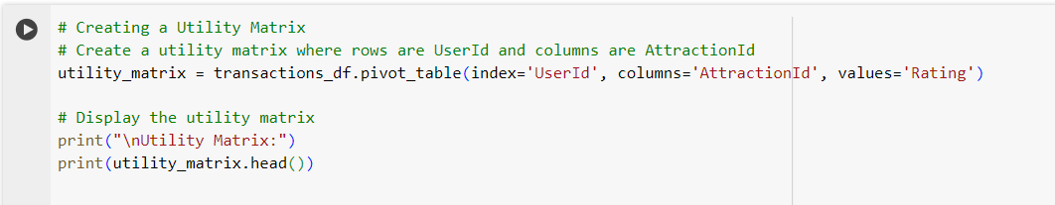Implementing Basic Recommendation Logic:

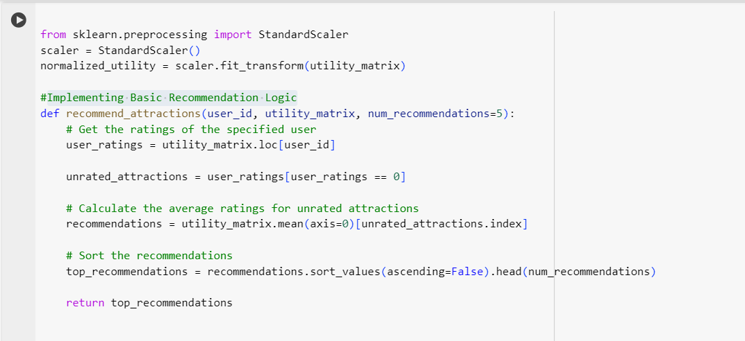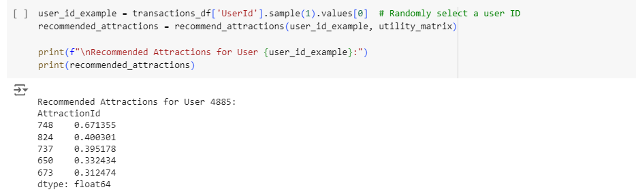

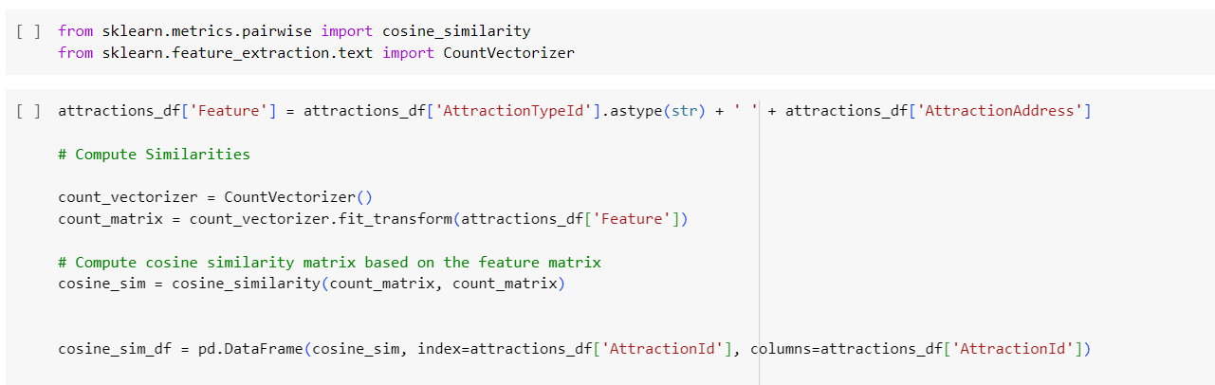

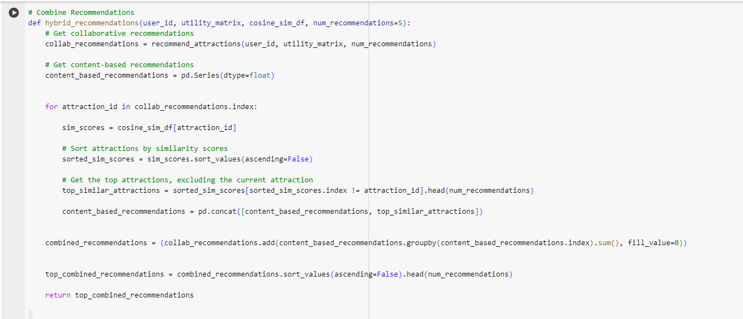



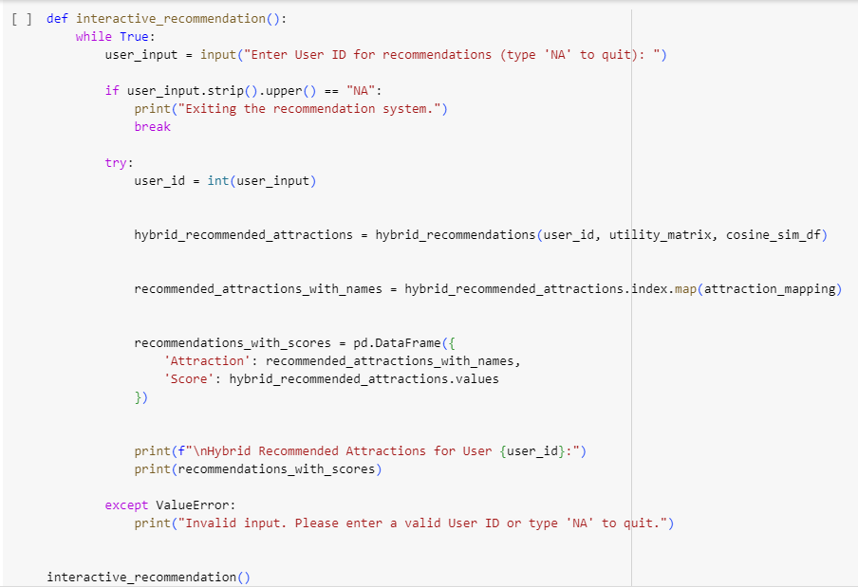

By using the pickle library, we serialize this data into a file named tourism_recommendation_model.pkl. This allows us to load the model later without needing to recompute or reprocess the data, facilitating efficient deployment and user interactions.

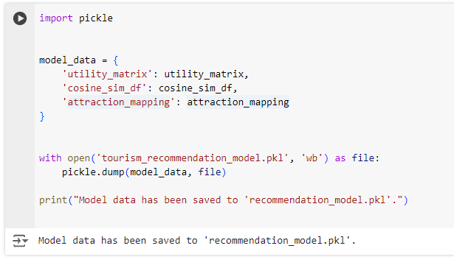

**Flask Application for AI-Driven Tourism Recommendation System**

This code snippet sets up a simple web application using Flask to provide users with personalized attraction recommendations based on their User ID. The application integrates the hybrid recommendation logic we developed earlier, leveraging both collaborative filtering and content-based filtering techniques.

When a user visits the application, they are greeted with a user-friendly interface that prompts them to enter their User ID. Upon submission, the application processes the input and returns a list of recommended attractions. This interactive approach ensures that users receive tailored suggestions that enhance their travel experience.

To make the application accessible over the internet, we utilize ngrok, which creates a secure tunnel to the local server running on port 5000. The public URL generated by ngrok allows users to access the application from anywhere. For instance, the public URL for this application is<https://7c50-34-125-5-97.ngrok-free.app>. This feature is particularly useful for testing and showcasing the application without deploying it on a full web server.

This Flask application embodies the essence of an AI-driven tourism recommendation system, providing users with insights into attractions tailored to their preferences, ultimately enriching their travel adventures.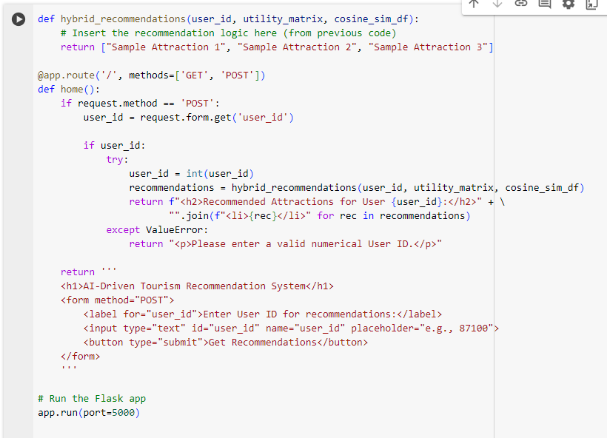

**Conclusion**

The development of the AI-Driven Tourism Recommendation System marks a significant step towards enhancing the travel experience for users by leveraging advanced data analysis and machine learning techniques. By utilizing a hybrid approach that combines collaborative filtering and content-based filtering, we have created a robust model capable of delivering personalized attraction recommendations based on individual user preferences. This innovative system not only provides users with tailored suggestions but also offers small business owners and vendors valuable insights into consumer behavior, enabling them to optimize their offerings and improve sales.

Throughout the project, we have meticulously prepared our datasets, conducted thorough analyses, and implemented the recommendation logic using Python libraries such as pandas, scikit-learn, and Flask. The use of a pickle file to save the model data ensures that we can easily load and deploy our model in a production environment. This approach highlights the importance of building scalable and maintainable solutions in the field of data science and machine learning.

Looking ahead, we recognize the necessity of making this application accessible to a broader audience. To achieve this, we need to upload our application to a cloud platform. Deploying the AI-Driven Tourism Recommendation System to the cloud will ensure that it is available to users anytime and anywhere, facilitating real-time interactions and enhancing user engagement. Cloud deployment will also provide scalability, allowing the application to handle increased traffic as more users access the system.

By hosting the application on a cloud platform, we can leverage the advantages of cloud computing, such as improved reliability, security, and cost-effectiveness. This transition is crucial for maximizing the reach and impact of our recommendation system, ultimately contributing to the growth of the tourism industry and supporting small businesses in the market. In conclusion, the successful implementation and cloud deployment of the AI-Driven Tourism Recommendation System hold the potential to revolutionize the way travelers discover attractions, making their experiences more enjoyable and tailored to their unique preferences.